

*Bachelor of Science in Computer Science (2016-2020)*

**Scope Document**

*For:*

**Atom**

**Brain-Computer Interfacing using Electroencephalography**

*Supervisor:*

**Dr. Yasir Faheem**

*Submitted by:*

|  |  |
| --- | --- |
| **Muhammad Faizan Badar** | **CU / FA16-BCS-054 / ISB** |
| **Kinza Arshad** | **CU / FA16-BCS-108 / ISB** |

Version 1.0

**COMSATS University Islamabad,  
Park Road, Chak Shahzad, Islamabad, Pakistan**

Department of Computer Science

|  |  |  |
| --- | --- | --- |
| **No.** | **Comment** | **Action** |
|  |  |  |
|  |  |  |
|  |  |  |
|  |  |  |
|  |  |  |
|  |  |  |

**SCOPE DOCUMENT REVSION HISTORY**

**Supervisor Signature**

**Date:**

**TABLE OF CONTENTS**

Abstract 1

Introduction 2

Problem Statement 2

Problem Solution for Proposed System 2

Related System Analysis/Literature Review 3

Advantages/Benefits of Proposed System 3

Scope 4

Modules 4

Module 1: Account Handling 4

Module 2: User Analytics and Statistics 4

Module 3: Specialized Control Training 5

Module 4: Entertainment Incentivized Training 5

Module 5: EEG Feature Extraction 5

Module 6: Database Handling 5

System Limitations/Constraints 5

Commercial Aspect 5

Tools and Technologies 7

Mockups 8

Project Stakeholders and Roles 9

Data Gathering Approach 9

Concepts 9

Conclusion 9

References 11

**Project Category:**

**A-**Desktop Application/Information System**/E-** Smartphone Application

**F-** Machine Learning

**Other (specify category):** Brain-Computer Interfacing

.com

# 

# Abstract

Brain-Computer Interface (BCI), also known as a neural-control interface, a mind-machine interface, etc., is the act of providing humans the access to the functionality, although not impartial, of computers, or any equally programmable and compatible device via the brain as the human input to this interface. Electroencephalography (EEG) is a medical non-invasive electrophysiological monitoring technique used to graph electrical brain waves, with its current usage in the domain of targeted and isolated research pertaining to the neurological and cerebral side of anatomy. EEG appears to be a reasonable approximation towards a starting point into creating a seamless BCI. The fundamental idea is to use this EEG to develop a BCI that can target issues pertaining to human activities. To be more specific, we’re aiming at providing a solution to the epidemic of excessive phone usage, which is one of the fore comings of millennialism, enhancing the attention span to improve focus in daily activities such as reading and others with similar brain involvement. We’ve chosen to divide the entire methodology into two streams; entertainment incentivized training and specialized controlled training, for example by games or any activity with self-perpetuating interest, and, monitored and visualized brain functioning during attentive activities respectively.

# Introduction

A brain-computer interface provides control of the system to the user with minimal or no physical interaction at all with the system itself, or, gives the user the power of “virtual telekinesis”. In any BCI, the brain can be said to be the primary peripheral with the cortexes as further specialized sub-peripherals. The working of our brain relies on an interconnected neural network, and this network either receives signals from receptors over the entire body and processes these signals, and/or, originates new signals containing information to perform specific actions like walking, sneezing, sleeping, focusing, concentrating or even just thinking. These signals flow in the form of electrical conductions and EEG can detect the inputs, processes, and outputs to this natural neural network, which involve the firing of certain neurons, as spikes or other spatial variations in the graphs, and each type of variation corresponds to a specific action or state of the brain. Depending upon the type of the variation, the BCI can utilize the relevant information and provide function dependent interfacing. A BCI can be a reasonable platform standing on the shoulders of which the epidemic of dopamine infliction and addiction can be fought to normalize and lengthen attention spans.

# Problem Statement

With the advent of millennialism, a decline in attention spans and dopamine infliction epidemic, have arisen problems that are at the core of society’s current situation. Effortless and seamless social networking platforms continue to grow and attract more and newer users towards in becoming part of the victims of social addiction. People spend most of their time scrolling through these applications looking for self-appreciation and self-appraisal, causing habitual time wastage. From a small part of the global community exists a population that use the brain-children of these tech giants for productive business activities and/or workflow collaborations. For others, scrolling through the updates and news of their social circle keeps them captivated and hypnotized. There have been many realizations about bad public interest [1] and the control that the big organizations have over the human mind. And so is the importance of Cognitive Training (CT) using certain BCIs [2]. Therefore, it begs the question, why isn’t a seamless and efficient input-output system, dependent on a BCI, a popularly approved or a heard off utility? Using the brain to provide specific actions or commands to the interface, considering the above mechanism of EEG, contains a vast array of problematic areas in aspects of existential measurability, signal-to-noise ratio, and seamlessness, i.e. EEG, which is held to be the center point of the BCI, lacks in providing clear distinction between inputs.

# Problem Solution for Proposed System

The general scheme of the above proposed methodology i.e. entertainment incentivized training and specialized controlled training, can achieve sufficient augmentation in the problem’s situation. Self-awareness is important to fight any problem of similar nature, because the cause and resolve should belong in the same environment for a victor to evolve. Achieving self-awareness, and/or more ultimately the required effect for better trained and focused cognitive minds and less dopamine addicted individuals, a reasonably equipped BCI is important, given that it may gain as much public interest as required, and that it is seamless and efficient. Now, towards a more practical and specific perspective, previous modular implementations of the entire project can be held as research standpoints to merge top-of-the-line research and popular off-the-shelf production. Li et al.’15 in *A Real-time EEG-based BCI System for Attention Recognition in Ubiquitous Environment* developed a base module which we can re-implement in a more reasonable way. Using a fine tuned, tech-equipped system and a minimalistic, likely to be usable interface is a way of developing a product.

# Related System Analysis/Literature Review

The first portable EEG headset was created in 2010 . After that this technology has been used in many ways for the betterment of humanity.

Table 1: Related System Analysis with proposed project solution

|  |  |  |
| --- | --- | --- |
| **Application Name** | **Weakness** | **Proposed Project Solution** |
| **TGAM Neurosky:**  an EEG sensor with limited electrodes | - Lacks detailed and informative brain reading EEG and a likeable  - Lacks captivating and interesting entry points into using and reusing the system | - A more high-end sensor from another headset manufacturer  - Developing a more likeable interface between the headset and the user |
| *A Real-time EEG-based BCI System for Attention Recognition in Ubiquitous Environment*  Li et al.’15 | - No such front-end at all | - At least a sub-module requiring user to interface with the system |

# Advantages/Benefits of Proposed System

* Users with availability of this application as parts of their daily lives can be more confident in their ability to focus
* The study and conceptual buildup in general of this endeavor may prove useful and a basis for further development in this field.

# Scope

So, in nutshell, our system is a BCI that detects the mental state of the user while he or she is using the provided utilities and from the detected mental state makes the prediction with some confidence that whether the user is paying attention or has lost focus. The BCI will achieve this using the hardware provisions of an EEG system, a headset, to gather brain wave readings and judge the state by using pre-programmed experience and a learnt model from previous examples. EEG defines its readings to be of five types of waves; namely the following:

1. Alpha: graphing the occipital lobe’s specifics regarding the visual stimuli,
2. Beta: graphing the fontal lobe’s specifics regarding the conscious thought and movement,
3. Theta: graphing sleep pertinent specifics and apparent in children,
4. Delta: partially sleep relevant specifics, while apparent in infants,
5. and Gamma: highest frequency waves ending spectral range,

and if a specific part or cortex of the human brain is targeted, depending on the requirement and the nature of the part of brain, then while performing the activity any change in the mental state can be detected by different fluctuations in all these different types of waves. The command center is located in the frontal lobe which is also responsible for the conscious thought and voluntary movement. Although targeting one cortex limits us from the other aspects of the mental state detection such as emotion recognition, social involvement, the human vision. This also limits the overall accuracy due to lower spatial averaging, upon which the entire system is based.

# Modules

## Module 1: Account Handling

Account profiling for normal users and admin users. This module provides users with the ability to login using their contact numbers and a password of their choice so that their personal progress and scores can stay private . Strict authentication rules are applied to ensure user privacy.

## Module 2: User Analytics and Statistics

* Monitoring of user’s brain condition over the period.
* Report generation and storage.
* User profiling and user-driven content upholding.
* Textual progress report is generated comparing when the user started using the application and present day. It compares the scores of the user collected over time .

## Module 3: Specialized Control Training

* A book reading application to monitor and train cognition during this activity
* Continuous background monitoring to record brain activity
* A quiz generated by the system from the pdf to test user focus.

## Module 4: Entertainment Incentivized Training

* Games and similar activities that have likeable user interaction
* Progress and levels within games to enforce coherent development in cognition
* Continuous background monitoring to record brain activity
* We are making 10 mini-games to provide user with a variety of choices.

## Module 5: EEG Feature Extraction

Encompasses the preliminary part of system development

* Labelled dataset collection and/or generation for supervised learning
* Machine Learning model architectural decisions and evaluations
* Extraction of features relevant to brain state and user attention

## Module 6: Database Handling

Firebase linking and standard database storage use cases so that admin can view all the data and draw meaningful conclusions .

# System Limitations/Constraints

* Perfectly relevant feature engineered dataset will be probably a risky estimation as of now, but feature vector extrapolation and unsupervised learning can be said to be solutions for this problem
* As development progresses, the direction of this projected scope may be altered especially after the hands-on experience with the headset
* A limitation of this project will be the task of emotion recognition, which seemingly is, if deduced from the neurological condition, impossible even in the disciplines of medicine

# Commercial Aspect

CT using BCIs is usually not a heard-off term in market or brand terminology as is Social Networking, but what both of these have in common is that they are much more classified as members of the same research framework and hence computer science terminology, than as market terminology, but the evolution of the latter into a market terminology is because the availability of social networking platforms. This is not to claim that under the scope of the umbrella of this project outcomes a deliverable that is equal to them in market value and user rating, but to provide a standpoint, which relies on the basis that there are no such limitations as the ones stated above, on which further commercial development is possible. Interfacing methods like audio and touch which have used the 2 primal senses i.e. vision and touch, despite their other limited uses, have begun to cripple the society, but capturing mind control as an interfacing method can only reiterate and reinforce the strength and importance of basic and advanced cognition.

* Direct Comparison: Augmented Reality (AR) is the hottest in market these days, and they are claiming to bring productivity in a more human involved and we are fighting that claim with our own spin using BCI

|  |  |
| --- | --- |
| AR is expensive | EEG is cheap |
| AR is like social media. Their initial intent is to increase productivity, but there is a deficit in computational resources | A focus monitored BCI, which we are designing can be used only for increased productivity |
| AR at the front-line is targeted for millennials who are technological geeks | We are not centralized on one population, we’re targeting millennials and intellects that want to bring productivity into their daily tasks |

# Tools and Technologies

Table 2: Tools and Technologies for Proposed Project

|  |  |  |
| --- | --- | --- |
| **Tools** | **Version** | **Rationale** |
| Colaboratory | - | Python code execution environment based on free cloud computational services to be used a priori to, and between application development |
| Unity | 2019.1.0 | Game development environment used to design and develop the mini games |
| Emotiv | Emotiv Mindwave | The preferred choice for the EEG headset to be used |
| Android studio |  | Developing the required front-end application |
| **Technology** | **Version** | **Rationale** |
| Python | 3.7 | The primary programming language for data diagnostics and machine learning, including several other dependencies |
| Java | Version 8 | Preferred for interfacing and application design on both windows and android |
| Firebase | - | Non-relational cloud database management system to be used for safe and agile data keeping and retrieval |
| C# | 7.3 | Programming language used to write scripts for game development |

# 

# Mockups

Login Screen

Account screen

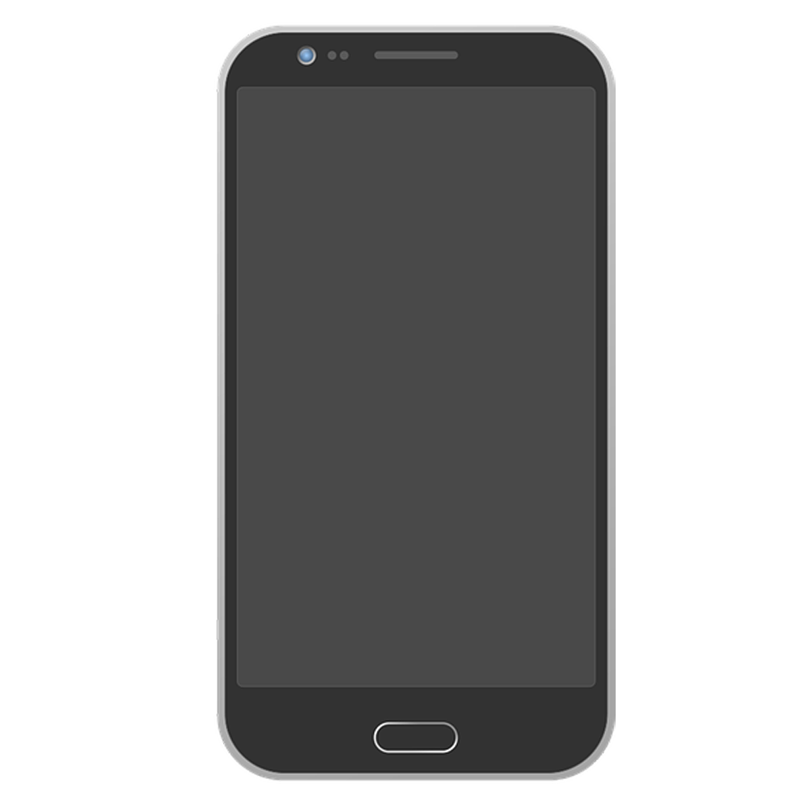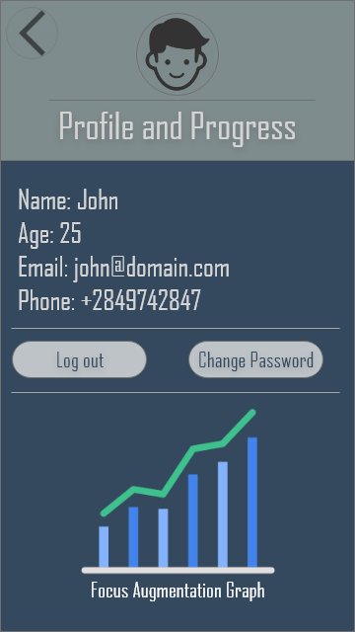

Main screen

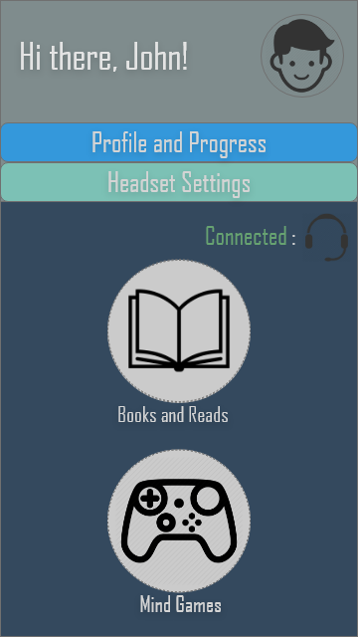

Bookshelf screen

Game choice screen

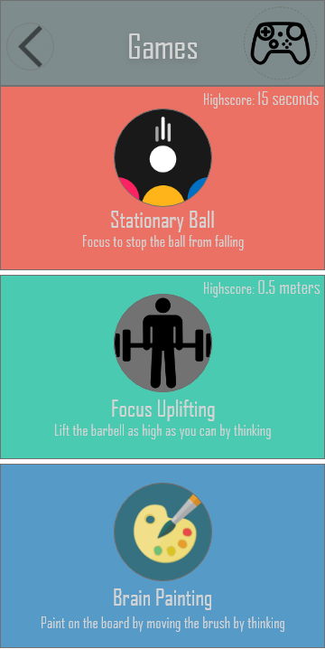

Book reader screen

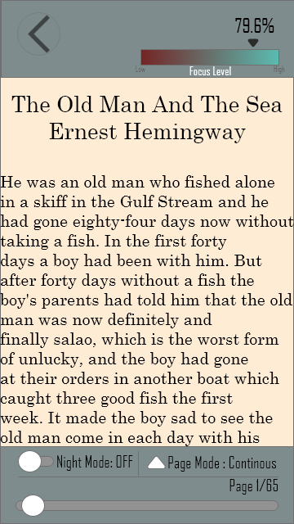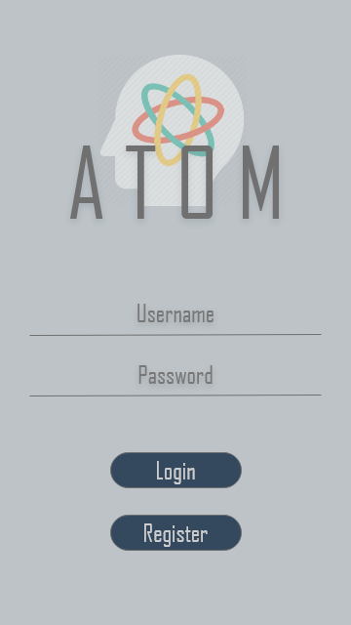

# Project Stakeholders and Roles

Table 3: Project Stakeholders for Proposed Project

|  |  |
| --- | --- |
| **Project Sponsor** | COMSATS University, Islamabad |
| **Stakeholder** | * Muhammad Faizan Badar * Kinza Arshad |

# Data Gathering Approach

* Three groups of users were made . One of teens , one of tweens and one of people in the range of 30 to 40.
* Simple shorthand interviews and sessions ranging from 15-30 minutes to test the model
* Questionnaires, Forms, Websites, Survey Sheets can be deployed for other non-technical market and consumer related speculations

# Concepts

* 1. Concept-1: Machine Learning
  2. Concept-2: EEG Analysis
  3. Concept-3: Neurocomputation and BCI in general
  4. Concept-4: Game design and development
  5. Concept-5: Artificial Intelligence (Lexical Analysis/Natural Language Processing)

# Conclusion

Considering the presented problem and the solution, its fair to estimate the importance and relevance of this project, and within or even beyond the projected scope, this project will hold reasonable grounds for further research and development. Not only is this this beneficial for the market at it will breed and environment of productivity but also a project worthy of investment and with potential to turn profit because we are attracting the general public, also in the process making them more productive in their society.

# References

[1] *Television and The Public Interest –* Newton N. Minor <https://www.americanrhetoric.com/speeches/newtonminow.htm>

[2] *Tuning Up the Old Brain with New Tricks:*

*Attention Training via Neurofeedback –* Jiang et al. ‘17